16 March 2026

Dear
LG 2432 – Climate-Related Hazard Areas & Marae Impact Assessments
I refer to your official information request dated 19 February 2026, where you requested the following information;
- All maps, datasets, assessments, or internal reports identifying areas within the Council’s jurisdiction that are identified as vulnerable to climate-related hazards, including flooding, coastal inundation, landslides, storm surge, or cyclone impacts.
- Any mapping or datasets identifying marae located within these vulnerable areas, including the name of each marae and the nature of the hazard affecting it.
- Any internal assessments and reports used to determine the vulnerability of marae to climate events.
- Any risk assessments, adaptation plans, or resilience strategies that specifically reference impacts on marae or Māori communities.
- What engagement has the Council undertaken with mana whenua regarding climate adaptation planning? And what feedback has been received from marae about climate vulnerability if any?
Response bullet point 1
Relevant information on Council files (including maps, datasets, assessments or internal reports) are the following; (available via this link – LG 2432 Documents ). Note that some of these reports do not specifically include a direct climate reference, but do relate to the type of hazards requested by this LGOIMA:
- Operative Manawatu District Plan Flood Channel Zones – these are available on the Council’s web-based mapping tool, located at this website: https://experience.arcgis.com/experience/9c83426858454ce3b978f566b3f7ce42/page/District-Plan?views=District-Plan-Layers%2CIwi-Statutory-Areas-Layers
- Report - Manawatu District Natural Hazards Foundation Report - Phase 1 - Perception Planning - January 2016.pdf
- Draft Plan Change A [Rural & Flood Channel Review] Appendix 8 – Flood Hazard Mapping Report 2025
- Draft Plan Change A [Rural & Flood Channel Review] Appendix 12- Tech Report Flood Channel Zone] 2025.
- Draft Plan Change A [Rural & Flood Channel Review] Draft Flood Hazard Avoidance area & Draft Flood Hazard Mitigation area: https://makeyourmark.manawatudc.govt.nz/district-plan-review/district-plan-review-map

Information supplied by Horizons Regional Council:
- Horizons has provided a number of flood models & information that affect land in the Manawatū District.
- HORIZONS REGIONAL PLAN MAPS (FLOODWAY AND LAND PRONE TO FLOODING)
- Horizons Floodways and Floodable Areas (Schedule 10 of Horizons One Plan) https://www.horizons.govt.nz/HRC/media/Media/One%20Plan/32-Part-5-RP-SCHED10-Floodways.pdf?ext=.pdf
- HORIZONS KNOWN FLOODING INFORMATION (BASED ON OBSERVATIONS) – REGION WIDE ...
Horizons regional modelled and inferred wet extents from FPM analysis
- Horizons River: Indicative Full Channel Extents (Region Wide)
- Horizons River: Indicative Full Channel Extents (Region Wide)
- Horizons Indicative Flooding Extents (Region Wide)
- SPECIFIC FLOODING EVENTS OBSERVED IN CHRONOLOGICAL ORDER (NEWEST TO OLDEST INFORMATION
- Horizons Observed Information for the October 2024 Flood Event (Manawatū District)
- Horizons Observed Information for the February 2023 Flood Event (Manawatū, Tararua, Rangitīkei and Palmerston North Districts) .
- Horizons Observed Information for the June 2015 Flood Event (Region Wide)
- Horizons Observed Information for the October 2013 Flood Event (Rangitīkei, Whanganui, Manawatū and Palmerston North Districts)
- Horizons Observed Information for the September 2010 Flood Event (Manawatū District – Makowhai Stream, Sanson)
- Horizons Observed Information for the February 2004 Flood Event (Region Wide)
- Horizons Observed Information for the 1988 Flood Event (Manawatū and Palmerston North Districts)
- Horizons Observed Information for the 1976 Flood Event (Manawatū and Palmerston North Districts)

- Horizons have also recently completed a vulnerability assessment on the lower Manawatū. Further information is available at: https://www.horizons.govt.nz/HRC/media/Media/Flood%20protection/2026-Flood-vulnerabilty-assessment-Lower-Manawatu-model-report-(Task-5,-FVA).pdf?ext=.pdf
Response bullet point 2
- Council has not completed a formal hazard assessment specifically for individual Marae located in areas identified as being subject to flooding hazards.
- However, this information can be deduced through existing GIS and district plan map data sources.
- The location of marae in the Manawatū District in relation to the district plan the Flood Channel 1 & 2 Zones: https://experience.arcgis.com/experience/9c83426858454ce3b978f566b3f7ce42/page/District-Plan?views=District-Plan-Layers%2CIwi-Statutory-Areas-Layers. Two screenshots of that data show the following (note that flood zones are shown in Blue):
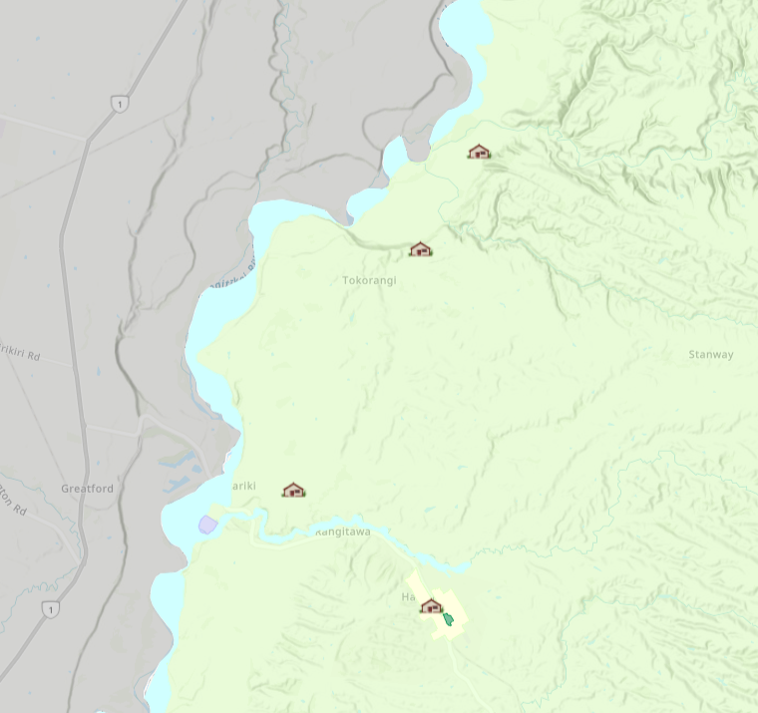
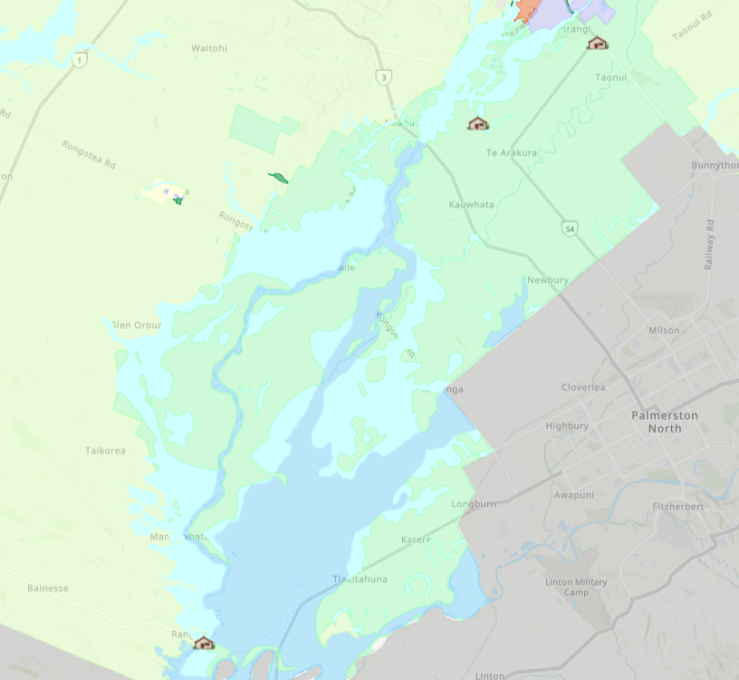

- This information can be accessed at the following link: https://experience.arcgis.com/experience/9c83426858454ce3b978f566b3f7ce42/page/Iwi-Statutory-Areas?views=Iwi-Statutory-Areas-Layers
- Overlaying the Marae locations with the flood models provided, three Marae are in close proximity to land identified as being subject to flood hazard risk information: Note this does not constitute a formal hazard assessment.
- Te Rangimārie Marae, SH 56, Rangiotu
- Kauwhata Marae, 148 Te Arakura Rd, Te Arakura
- Aorangi Marae, 24 Waughs Road, Feilding
- The following maps show these in more detail:

- Te Rangimārie Marae, SH 56, Rangiotu – [marked with green dot]
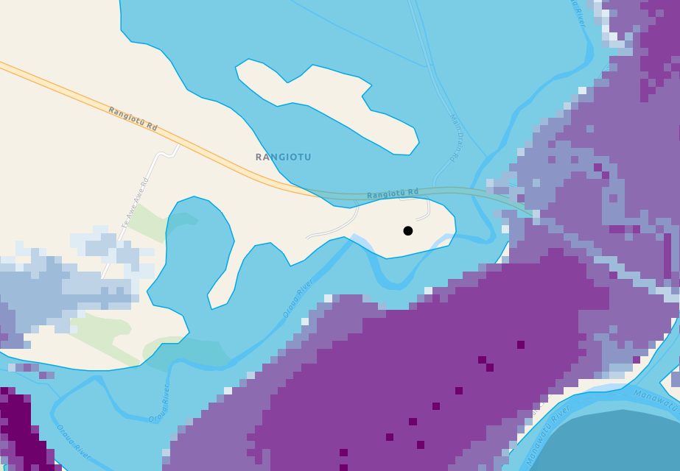
- Kauwhata Marae, 148 Te Arakura Rd, Te Arakura
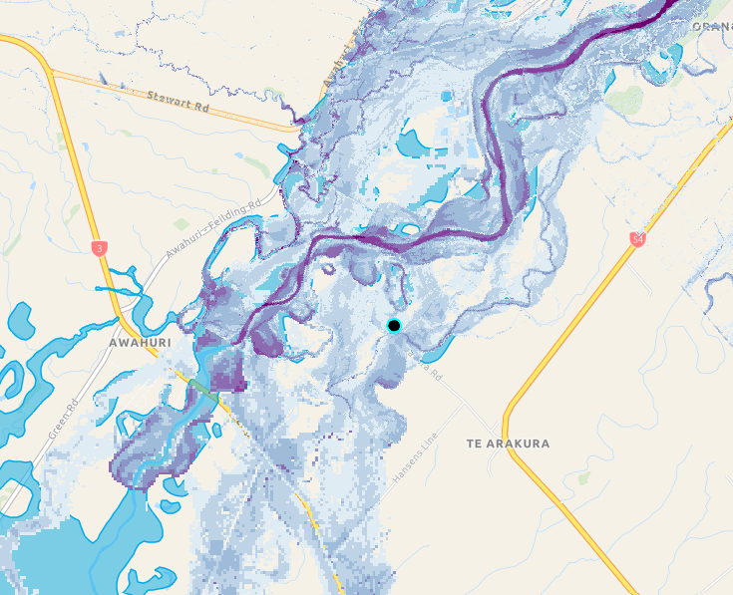
- Aorangi Marae, 24 Waughs Road, Feilding
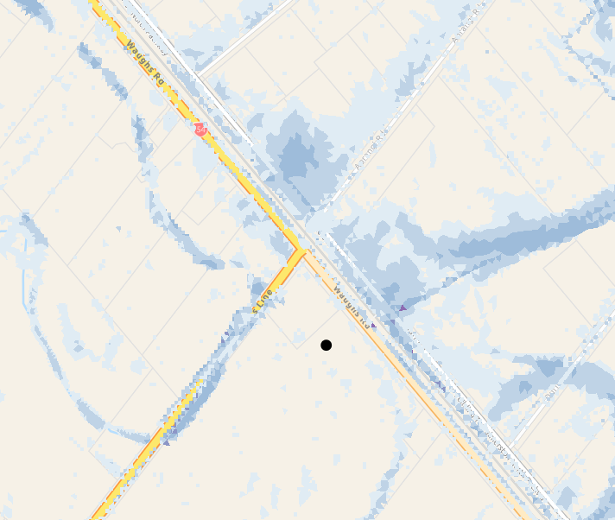

Response bullet point 3
- Council commissioned consultants Allan+Clarke in 2021 to produce a report on the impacts of climate change on Manawatū District’s primary industries, and the roles and responsibilities of local government. Although this report was not specifically targeted at assessment risks to marae, it highlighted the following: -
- Risks to Māori social, cultural, spiritual and economic wellbeing from loss and degradation of lands and waters, as well as cultural assets such as marae, due to ongoing sea-level rise, changes in rainfall and drought;
- Risks to mental health, identity, autonomy and sense of belonging and wellbeing from trauma, due to ongoing sea-level rise, extreme weather events and drought.
- Risks to Māori and European cultural heritage sites, due to ongoing sea-level rise, extreme weather events and increasing fire weather.

Response bullet point 4
- The Horizons Regional Council’s Manawatū-Whanganui Regional Climate Change Risk Assessment (2021). The work was carried out by consultants Tonkin and Taylor and explicitly assesses marae (and related taonga such as pā sites, urupā and papakāinga) for vulnerability to climate hazards. It applies a risk assessment framework (exposure, sensitivity, adaptive capacity) consistent with the IPCC/NCCRA approach and provides qualitative risk ratings across time horizons (present, 2050, 2100).
- The risk assessment includes hazard-by-asset tables that explicitly score risk levels for marae/taonga and relevant supporting systems (public spaces, housing, roads, flood schemes)—information that can be used to determine and prioritise marae vulnerability and adaptation needs. Please refer to sections 6 and 8 of the document. Link found here: 20210902_Horizons-CCRA_Report-signed_1.pdf

Response bullet point 5
- Tangimoana Project
The Manawatū District Council has undertaken initial climate adaptation planning in Tangimoana, which is recognised as one of the district’s most climate-exposed communities. This work builds on the earlier Deep South National Science Challenge research project led by Massey University, which examined coastal hazards and long-term climate risks affecting the area.
Subsequent adaptation planning discussions have been jointly supported by Horizons Regional Council and Manawatū District Council, reflecting the shared statutory responsibilities across local and regional government in managing natural hazard risk and climate resilience.
Horizons Regional Council has taken the lead role engaging with mana whenua in adaptation work at Tangimoana. As such, Horizons would be best placed to provide detailed information regarding the specific nature of engagement undertaken with mana whenua at Tangimoana.
Manawatū District Council remains committed to working collaboratively with mana whenua, regional partners, and affected communities as climate adaptation planning progresses.
Manawatū District Council engaged with marae through hui to discuss emergency management and the drafting of Marae Emergency Preparedness Plans. Within the sessions the marae were asked to identify and discuss hazards for their own marae for collation within their plan. At the end of the sessions the marae were asked to complete their plan and file it with the Council, if they considered it appropriate.
- Marae emergency preparedness (TPK) and Feilding Flood Resilience work: While not specifically about climate adaption:
  - Council worked with Marae representatives at two hui on 6 August (with Te Puni Kōkiri) and 1 October 2023 on Marae preparedness in an emergency. Each marae has a Marae Resource Pack Planning Toolkit.
  - Kauwhata Marae representatives are participating in the Feilding Flood Resilience Governance Group which is a group comprised of Horizons regional councillors, Manawatū District councillors, Iwi and land owner representatives. This governance group exists to make Feilding and Te Arakura more flood resilient. Te Arakura was included because that is where the Kauwhata Marae is located which is vulnerable to flooding.
Council has also strengthened its engagement with marae through the establishment of formal relationships between marae committees and elected members. Following strong engagement from marae committees during the development of the 2024 Long Term Plan, Council resolved to recognise marae committees in a similar way to the district’s community committees. This includes providing a liaison councillor for each marae, a small operational budget, and the ability to apply for additional funding through a contestable fund. Work is currently underway to confirm liaison councillor appointments for the current triennium. These relationships are intended to support ongoing communication between marae committees and councillors on matters affecting marae, including natural hazards, emergency preparedness, and climate adaptation.

Manawatū District Council publishes responses to Local Government Official Information and Meetings Act 1987 (LGOIMA). We will publish the LGOIMA response along with a summary of the request on our website. Requests and responses may be paraphrased.
To protect your privacy, we will not generally publish personal information about you, or information that identifies you.
If you wish to discuss this response with us, please feel free to contact the LGOIMA Response Team on 06 323 0000 or by replying to this email.
Yours sincerely,

